**CNSL Lab Assignment 7**

**Neeti Kurulkar**

**Use packet tracer tool for configuration of 3Router Network using one of the following**

**protocol RIP/OSPF/BGP**

1. **Network topology**

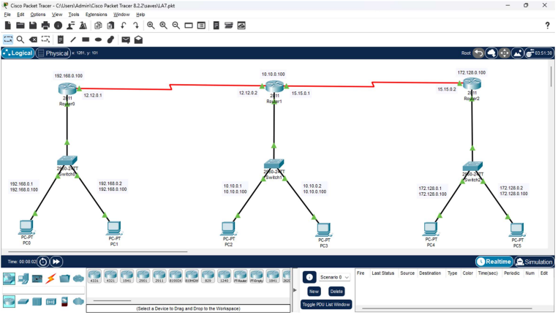

1. **Routing Configurations**

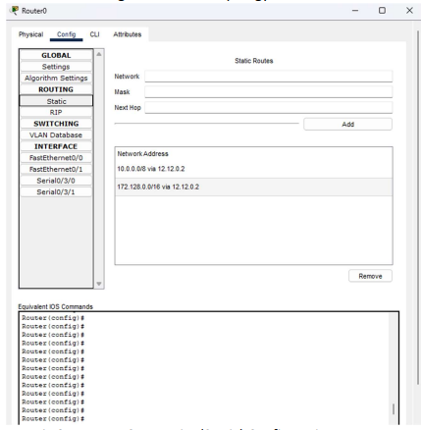

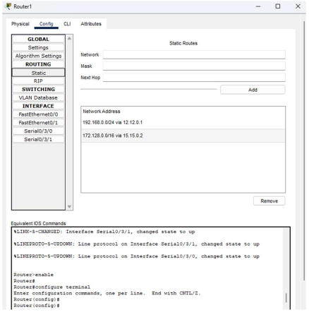

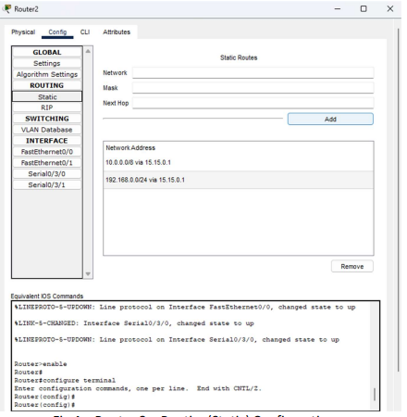

1. **Checking connectivity from PC0 to other Nodes**

